Prof. Dr. Uwe Spiekermann
(Visiting Professor during the spring term of 2006)

Main Research Interests

- History of 19th and 20th Century Consumption
- History of 19th and 20th Century Retailing
- History of Economic and Natural Sciences
- History of Marketing

Research Activities

Uwe Spiekermann’s major research focus in 2006 was the history of 20th century German nutrition. He continued his work on his habilitation project “Künstliche Kost. Die Durchsetzung der Wissensgesellschaft und die Erfindung der modernen Ernährung in Deutschland 1880-2000,” funded by the Deutsche Forschungsgemeinschaft: Since the late 19th century science, market and society were established and differentiated as specific systems, characterized by their own rationality and heterogeneous types of efficiency. This was a typical element of “modern” knowledge societies: Growing opportunities and wealth were accompanied by structural uncertainty, growing risks and hazards. Practical and objective knowledge were more and more diverged, frictions and tensions among everyday experience and systemic logics became typical. The project will analyze emergence, development and consequences of a knowledge society by analyzing nutrition and eating in Germany as an example. The implementation of a new scientific understanding of food and nutrition, based on nutrients and physiology, altered the traditional relationship of nature and culture fundamentally. This invention of a “new” nutrition led to new and more efficient ways of supply, production and distribution, which are analyzed in detail. On the other side nutrition and eating became an oscillating field of public and individual fears and hopes, which stress structural problems of knowledge societies in the age of affluence.

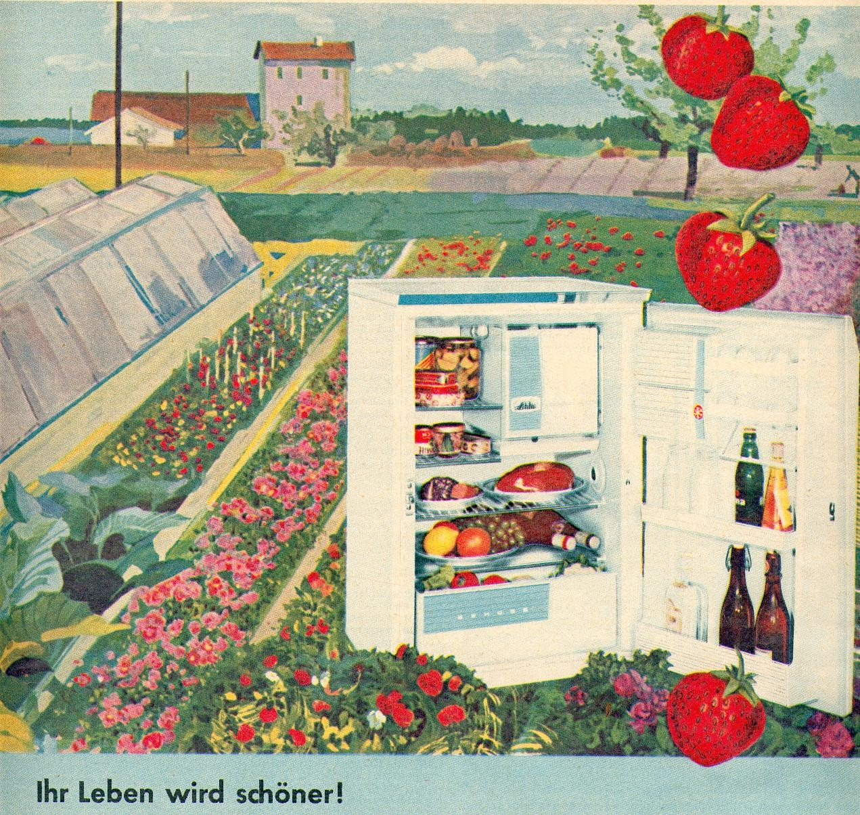

Cultivation and Civilisation: Advertisement of Linde refrigerator, 1959

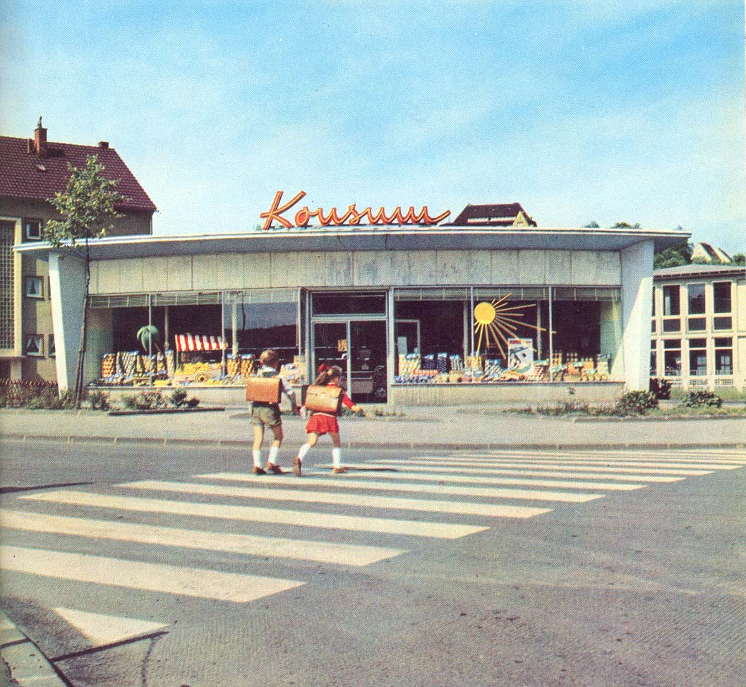

On the way to a unknown world of affluence, Dortmund 1959

In addition to this project Uwe Spiekermann continued work in his main research areas, mainly in the fields of marketing and retailing. Additionally he arranged (together with two colleagues) a conference on the “History of beer consumption and marketing in 19th and 20th century”, sponsored by the Gesellschaft für Westfälische Wirtschaftsgeschichte, which will take place in Dortmund in June 2007.

Funded Projects

Scholarship of the Deutsch Forschungsgemeinschaft for the Project “Künstliche Kost. Die Durchsetzung der Wissensgesellschaft und die Erfindung der modernen Ernährung in Deutschland 1880-2000” (01/2006; 06/2006ff.)

Other Professional Activities

- Editorial Committee of “Food and Foodways” (Taylor & Francis)
- Steering group of the “New Nutrition Science Project” (Global network, supported by the International Union of Nutritionists)
- Scientific advisory board of “Ernährung im Fokus” (Aid)
- Scientific advisory board of “OSSENA – Ernährungsqualität als Lebensqualität” (Research project, financed by the Federal Ministry of Education and Research)
- Scientific Jury of the “Förderpreis Ernährungskultur”, sponsored by the Johannes Fehr GmbH & Co. KG
- Visiting lecturer at the University of Vienna, Department of Nutritional Sciences: Lecture/Seminar “Kulturgeschichte der Ernährung”
- Several Radio-Interviews with NDR, WDR, SWR, MDR, mainly on the history of nutrition and retailing.

